**Synoptic Project – Media Organiser**

**Design**

After reading through the documentation that was given to me, I decided it would be best to create a wireframe and a prototype that I could work towards. As we can see below for the wireframes, I have annotated and created a skeleton for the media organiser for each of the pages I will be creating.

**Home**

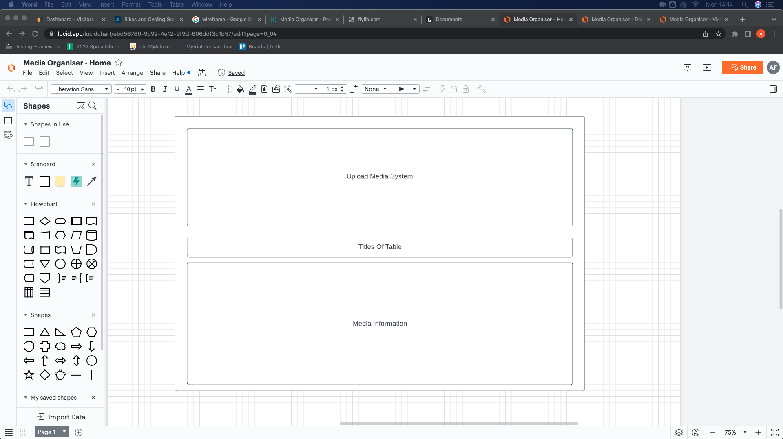

**Delete**

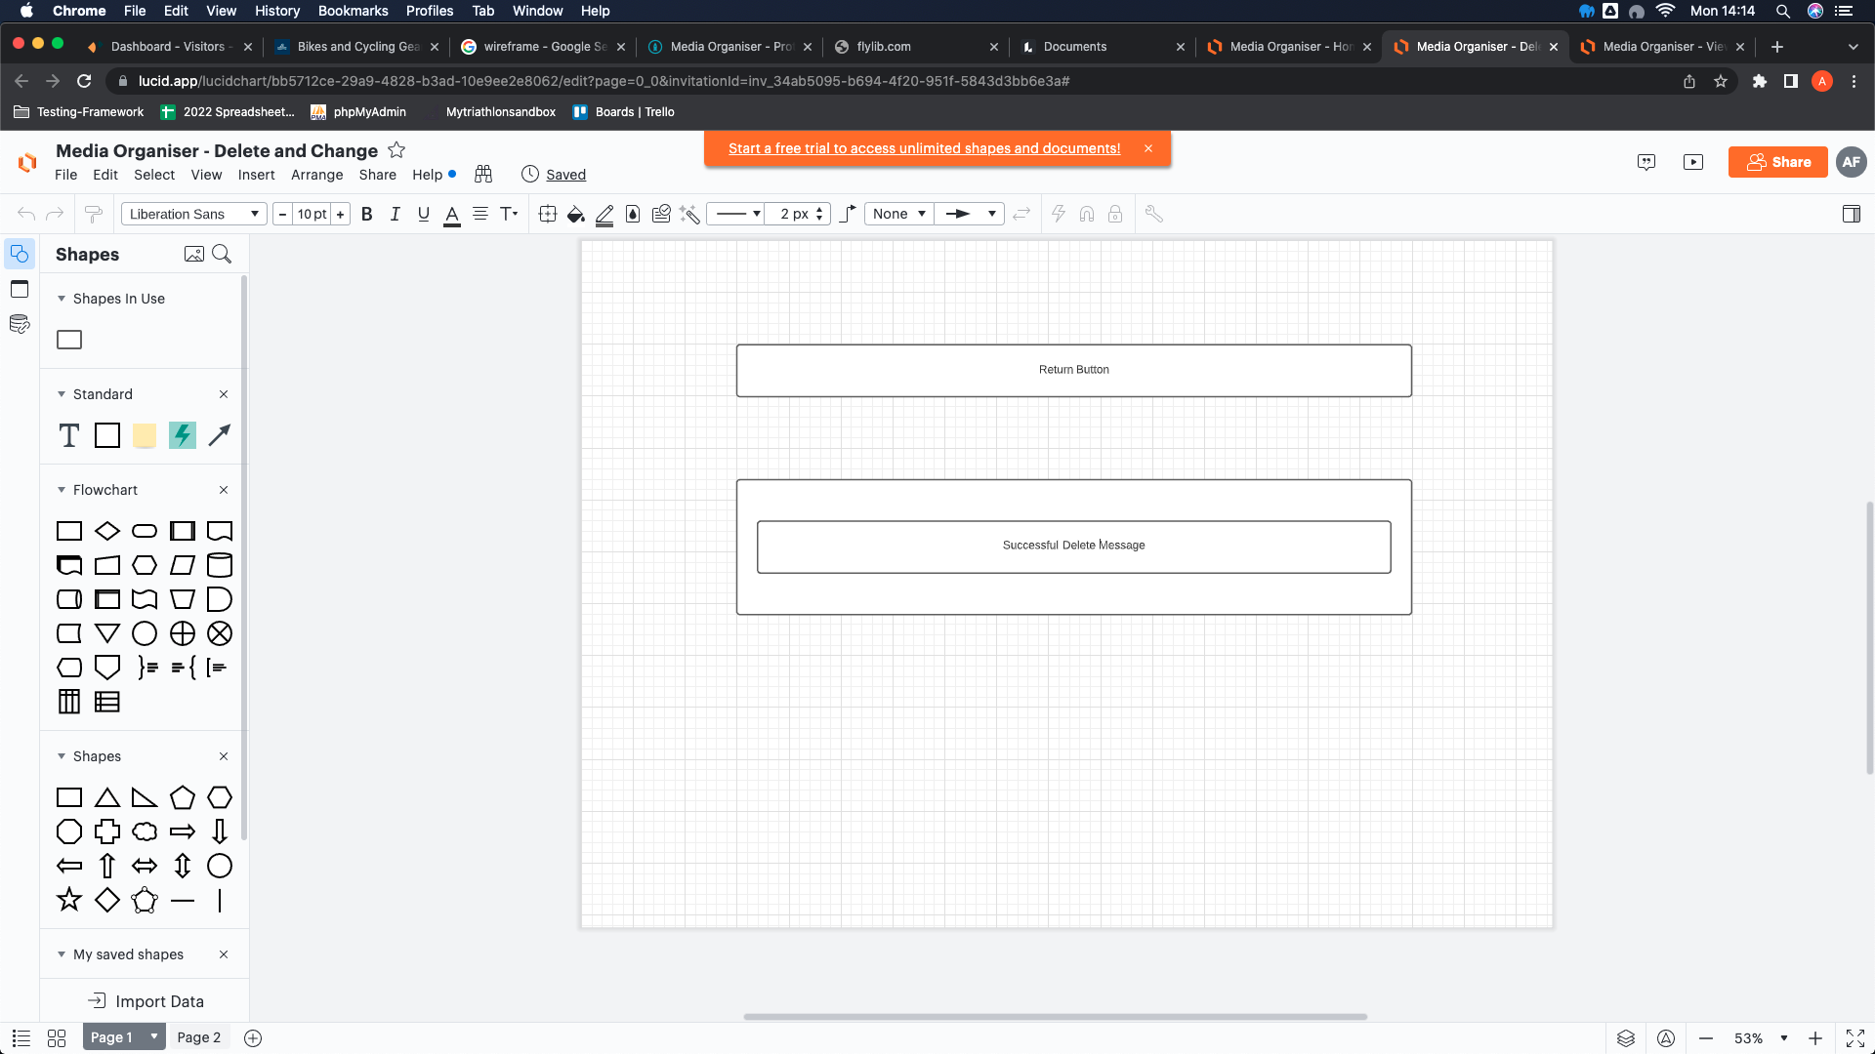

**Change**

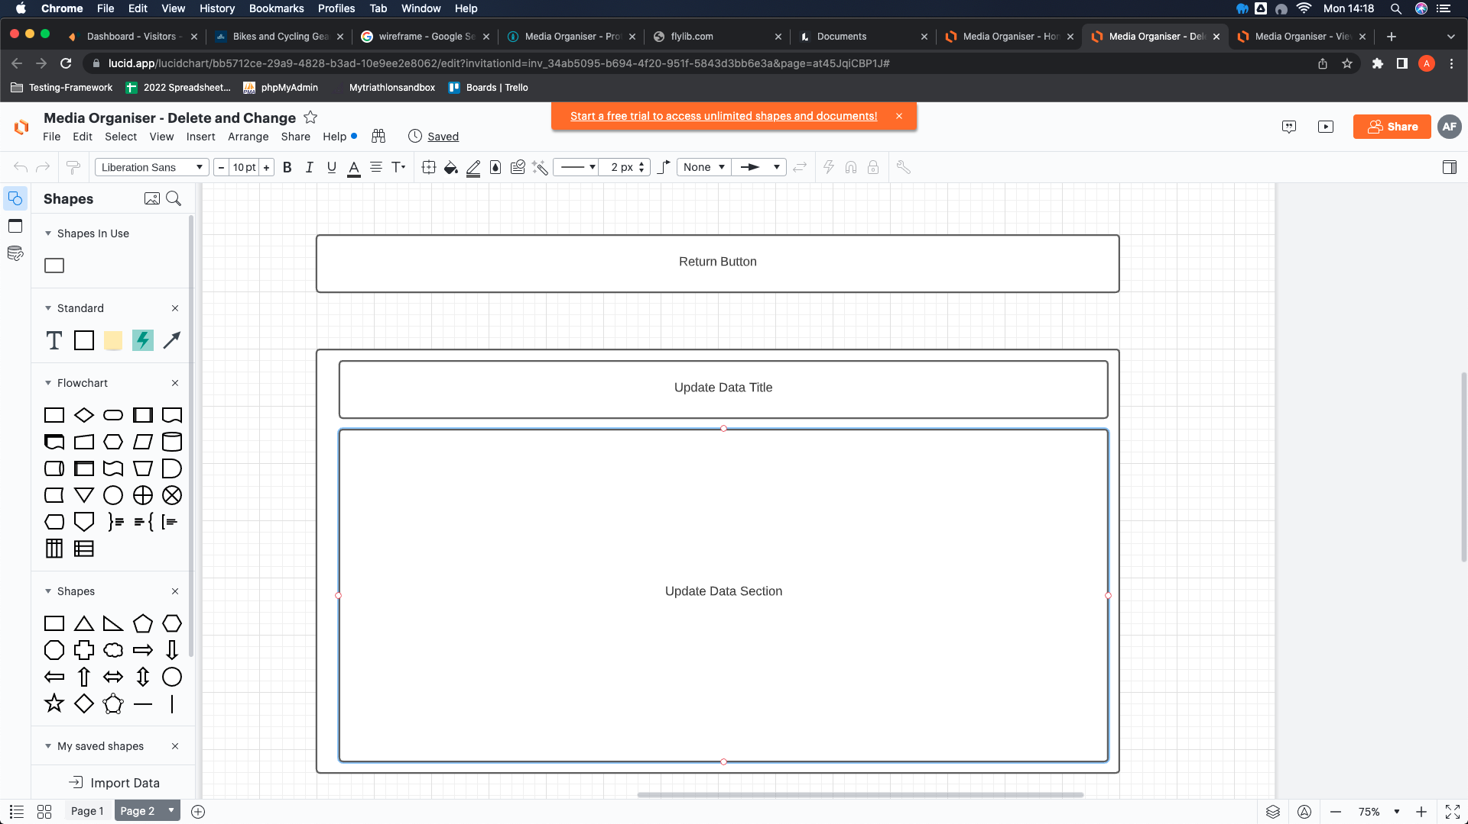

**View**

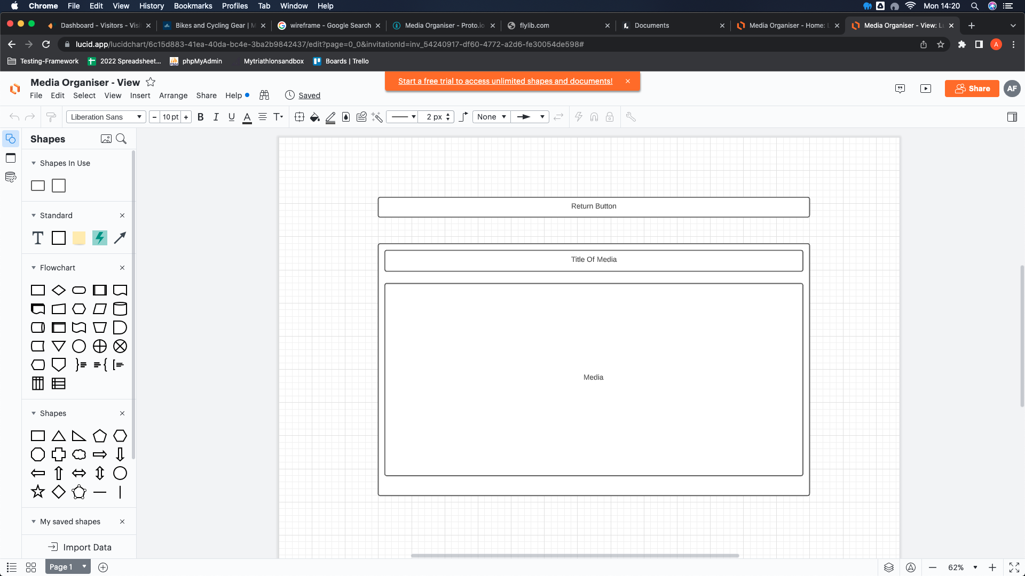

After the skeleton of the wireframe was created, I was able to build a prototype that I would use to build the media organiser.

**Prototype**

As we can see below, the prototype created is in depth and links between all the pages shown. As we can see, there is an area in which the user will be able to upload the media that they would like, it will then be displayed in the table as shown below. If a user clicks the view media button, they will be able to view that media as shown below. If a user would like to delete or change anything about a media record, they can with the two buttons to the right, as shown below they will then be taken to the delete page to show that record has been successfully deleted or the update page where they can update any information, they need to about the record.

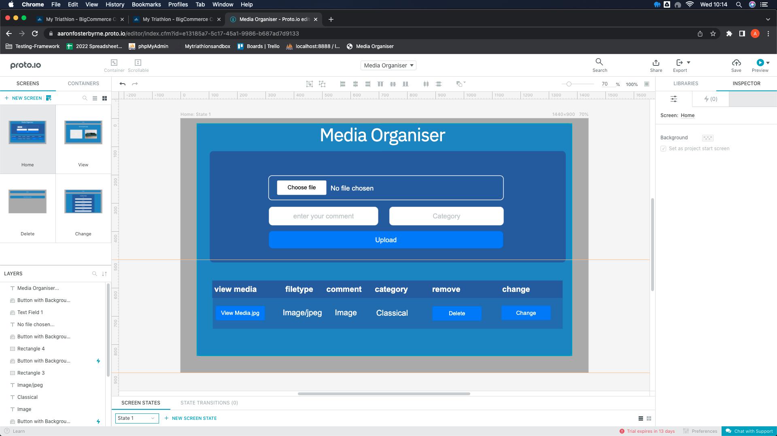

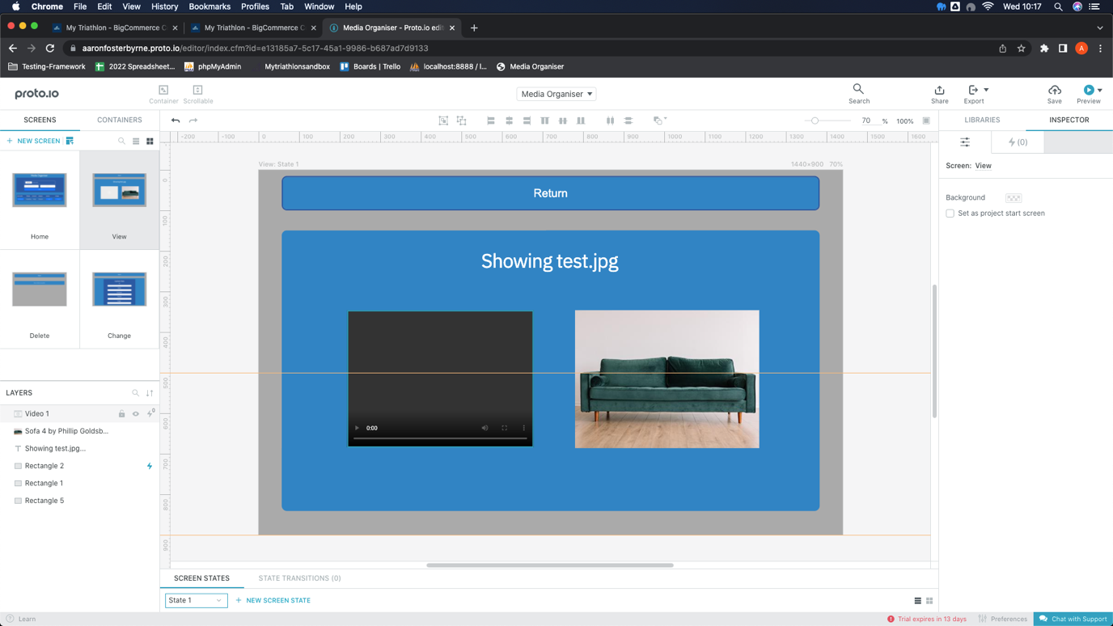

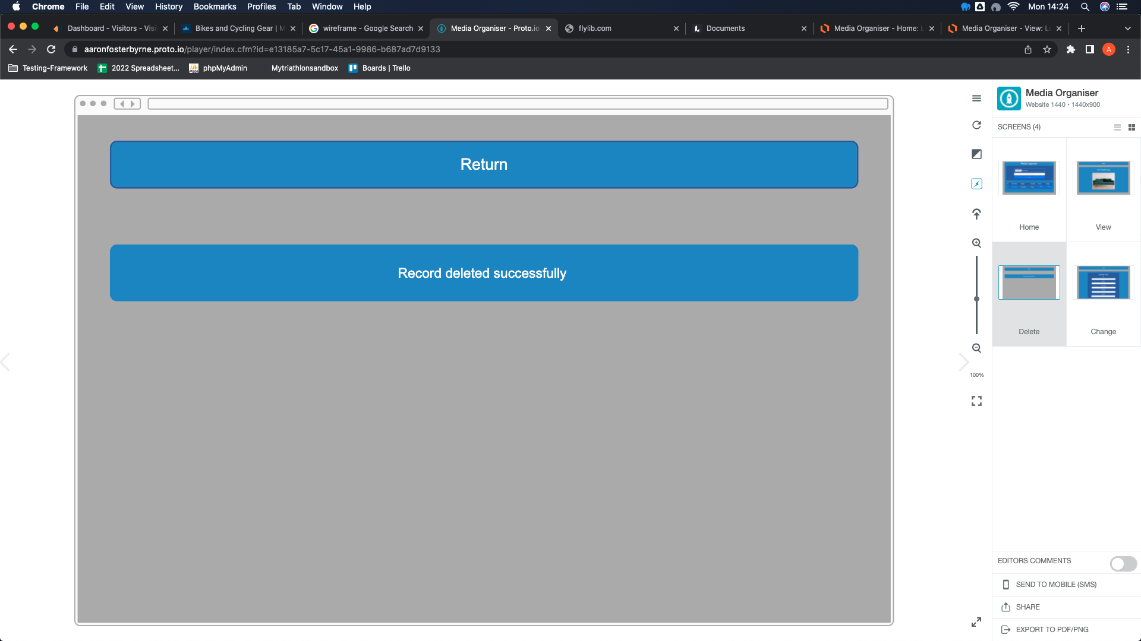

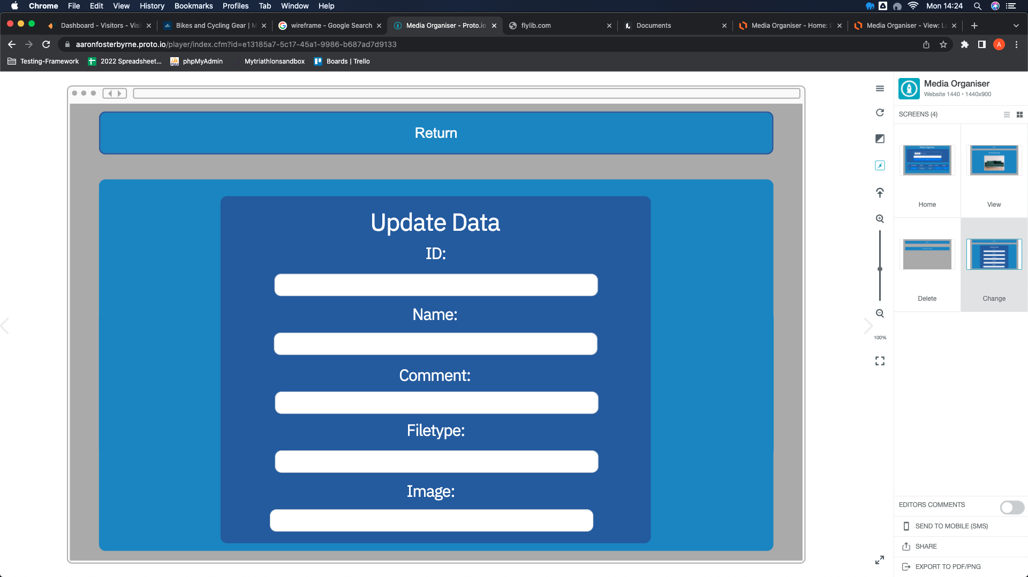

**Construction**

As soon as I created a prototype in which I was happy with, I started working on the programming of the media organiser. The first thing I did was create an index.php page which would pull through the table and where the user will enter the media they would like to add to the table. As we can see the first thing I did was include the database.php, this was so that the database was connected to the file when we pull through the information needed. We then moved onto creating the html skelton which as we can see I have used both indentation and comments to make the file clear and to follow good coding standards. This is also where the user will be able to upload any media they like through the use of a form. At the very bottom of the code is the use of including the fetch_playlist.php file, this is there to pull through the table of recorded media added by the user.

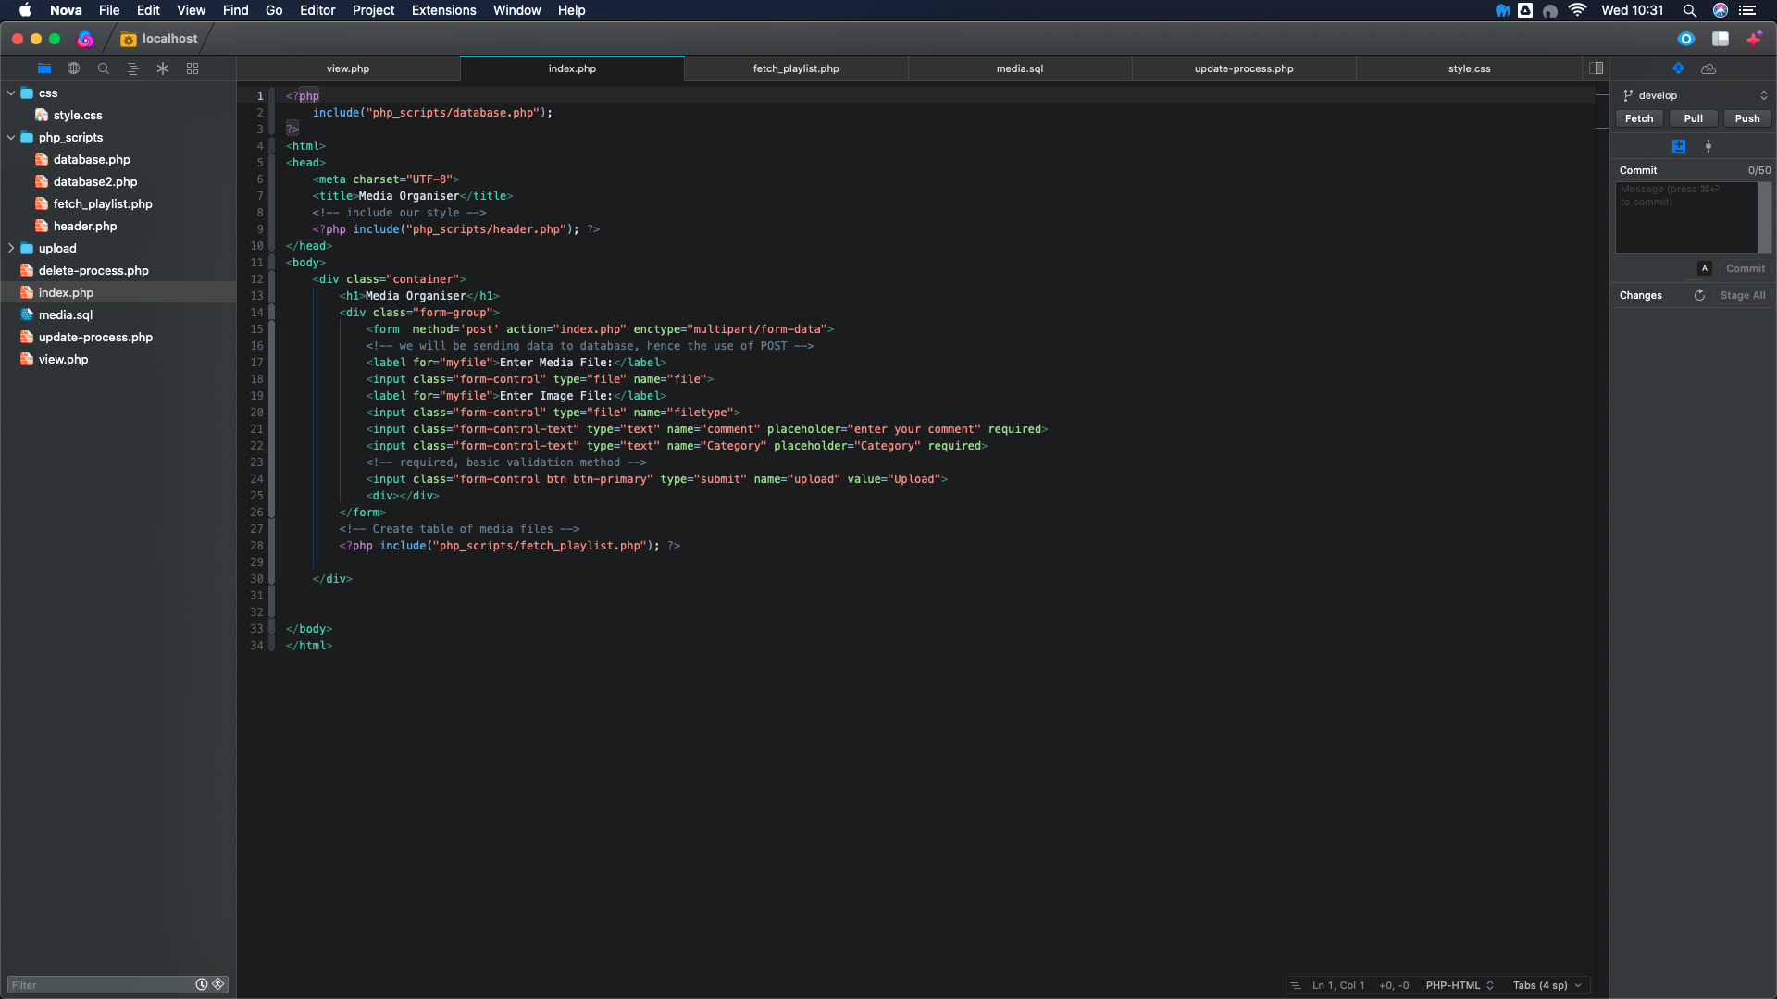

The next thing I did was create the database file in order to connect to the database and also to enter the information into it that the user has provided. Once again, I have used comments inside the file in order to follow good coding practices and to make sure the file is easily readable. As we can see inside the file, I have connected the database using a mysqli_connect and also written SQL queries in order to add the information into the database from the user.

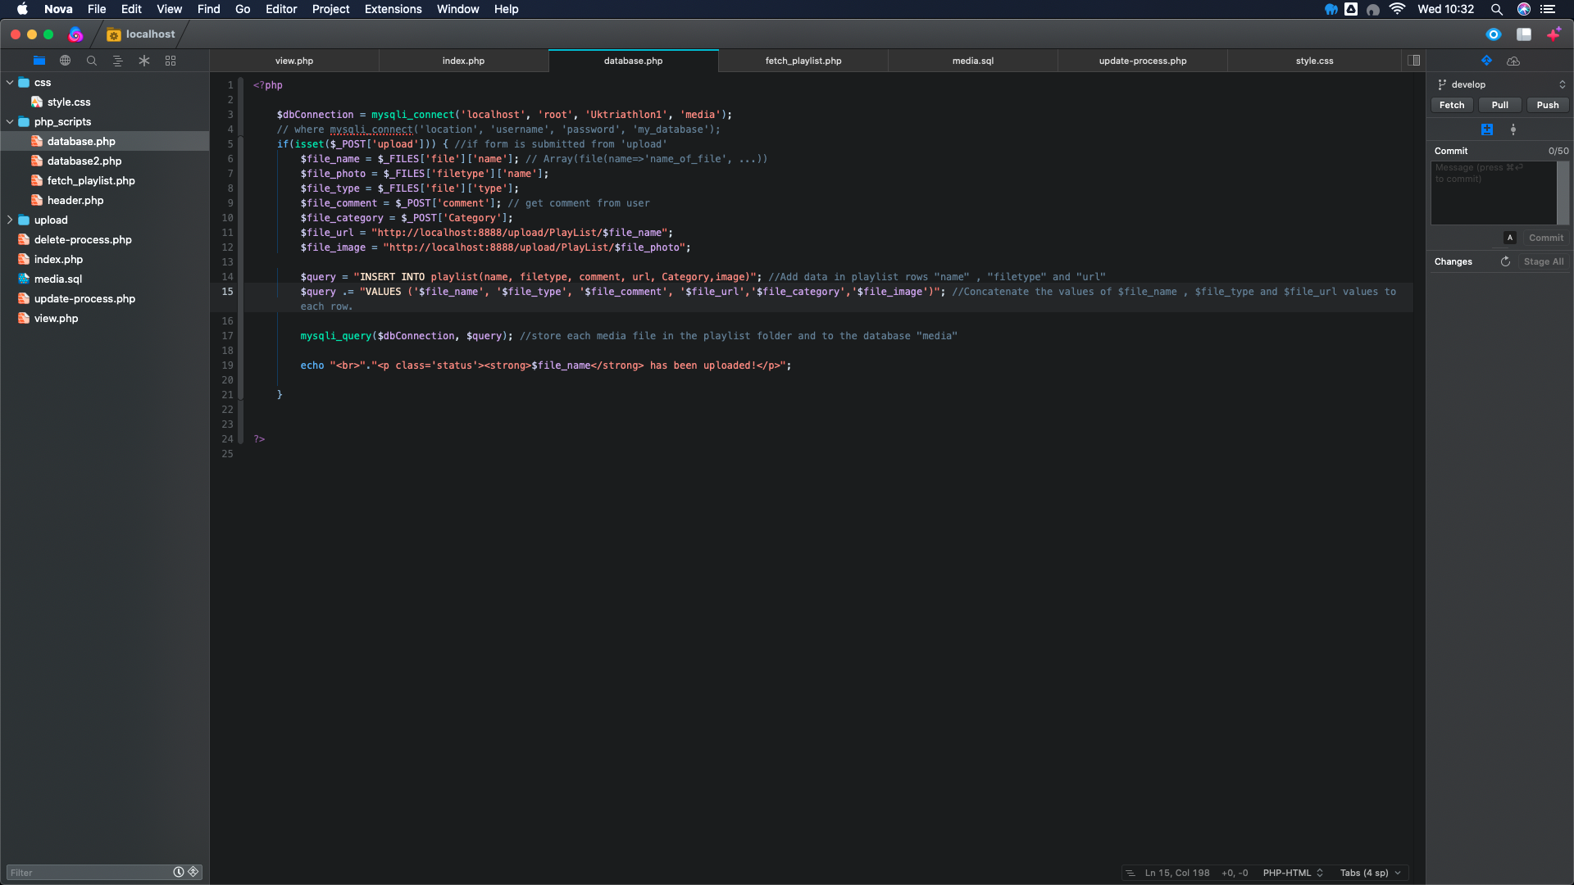

As we can see in another database file, I have used a simple connection which will later come in handy when creating the update and delete php files.

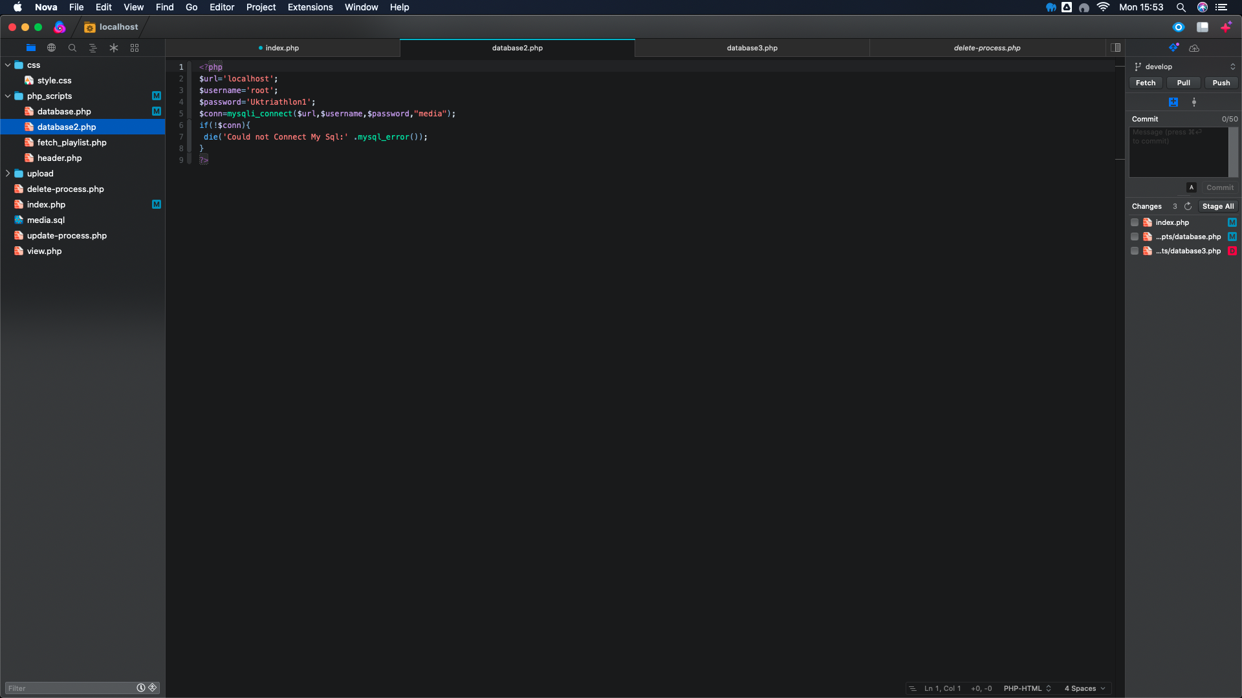

The next big task for me I completed was the creation of the fetch_playlist.php which included the table of the media information along with an SQL query to pull through the information needed. Once again as we can see I have included comments to show what each part of code is for and why it is being used.

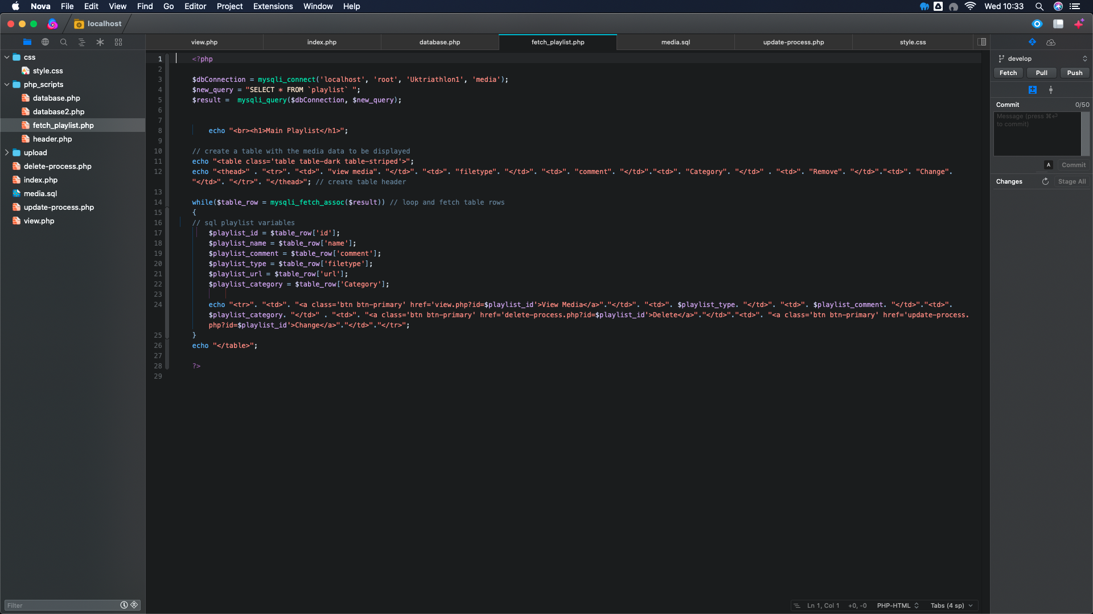

The final php file I made in the php_scripts folder was a header file which is used to link the styling file, create the viewport and also link bootstrap in order to use it.

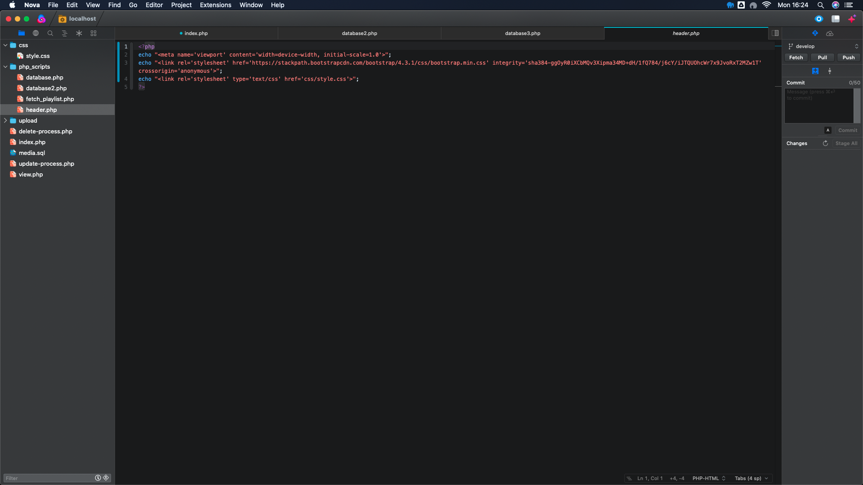

Another php file I had to create was the delete-process.php file, this was so users were able to delete files that they did not need. Once again, I have included comments and indentation to make sure that the code is clear, the php used in this file allows for the record the user wants to delete to be deleted from records by pulling through the id of that record.

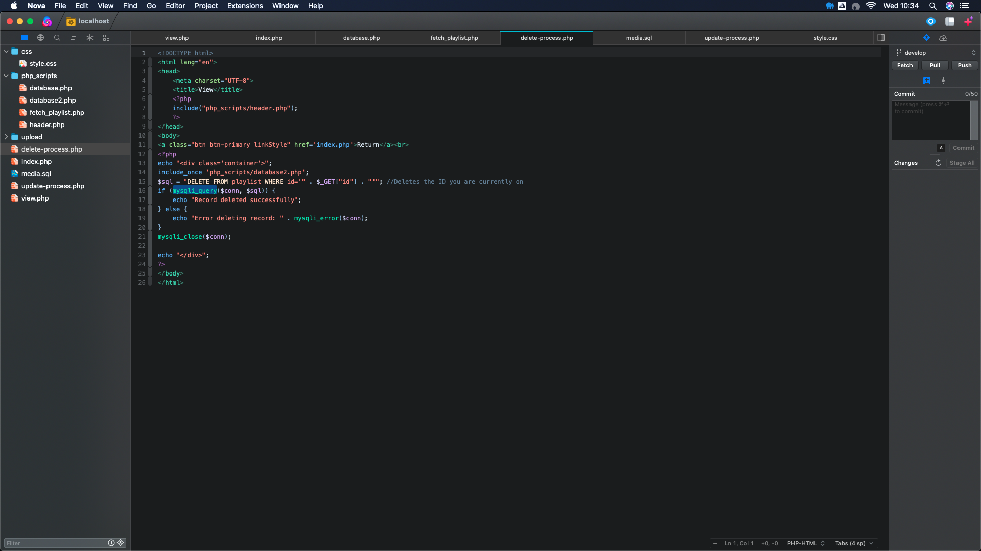

Another file I created was the update-process.php file which allows users to update the media records if they need to such as changing images, music etc. I have included comments and indentation again to make code clear.

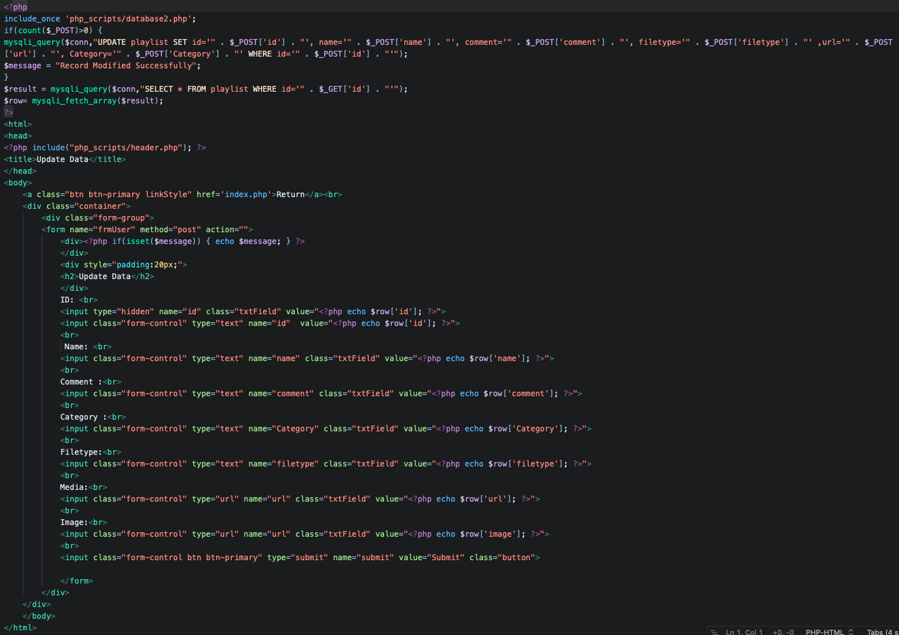

The last two files I created were the media.sql file and the style.css file. I created the media.sql file to make an easy import of creating the database required in order to save the information the user has given. I have also made the style.css file in order to design the project equivalent to the prototype that I designed, samples of both of these files included below in the screenshots.

